# Social Media Management with Approvals

## Social Media Flow

1. Create a list item with content to post
2. Automatic: Message to team requesting approval
3. Approve the list item
4. Automatic: shorten URL
5. Automatic: Post to LinkedIn
6. Automatic: Post to Facebook
7. Automatic: Post to Twitter
8. Automatic: Post to Instagram

## How to Build an Automated Social Media Management Tool using Office 365

1. Create an Office 365 Group
2. Add members to group
3. Create a Microsoft Team from the Office 365 group
4. Create a SharePoint list
5. Add approval to list

## Create an Office 365 Group

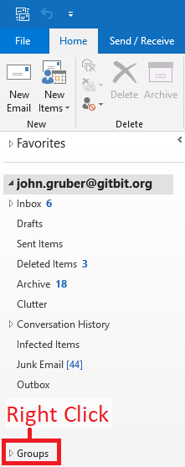

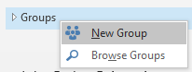

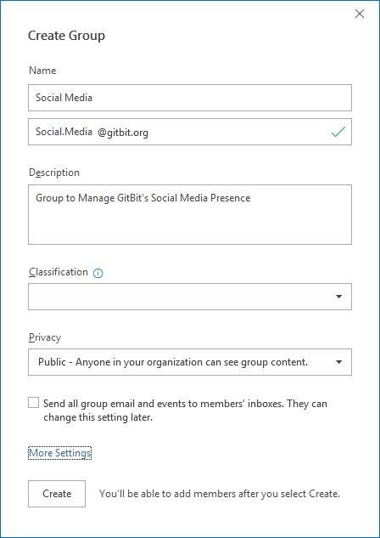

## Add Members to the Group

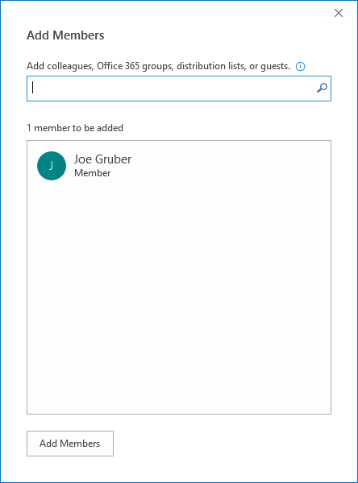

# View the Group Inbox

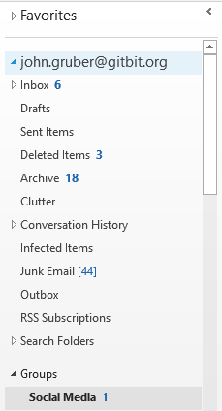

# Setup the Group

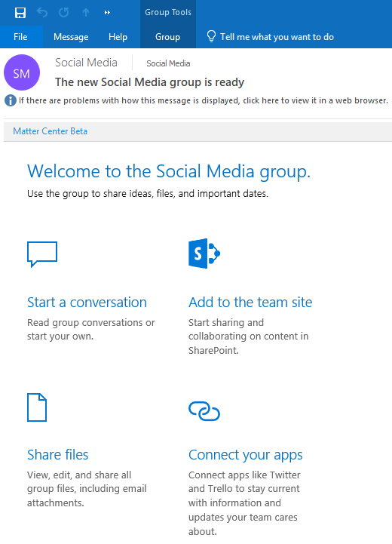

## Connect to Social Media

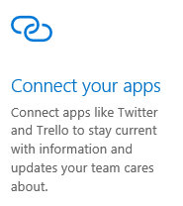

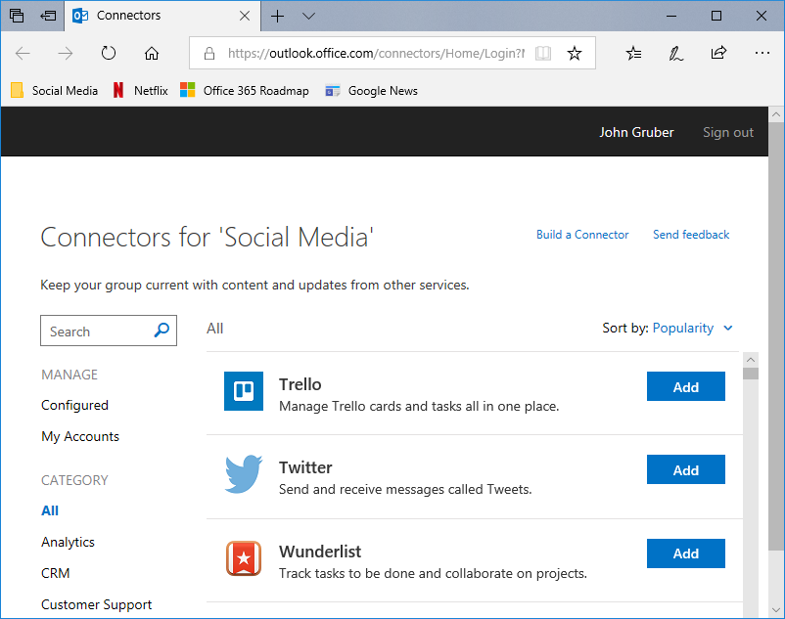

### Setup Twitter



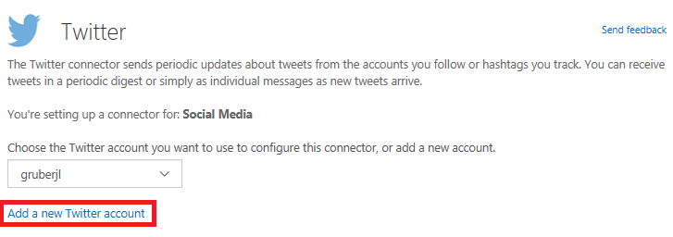

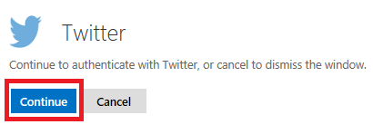

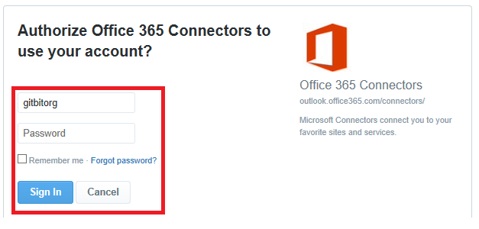

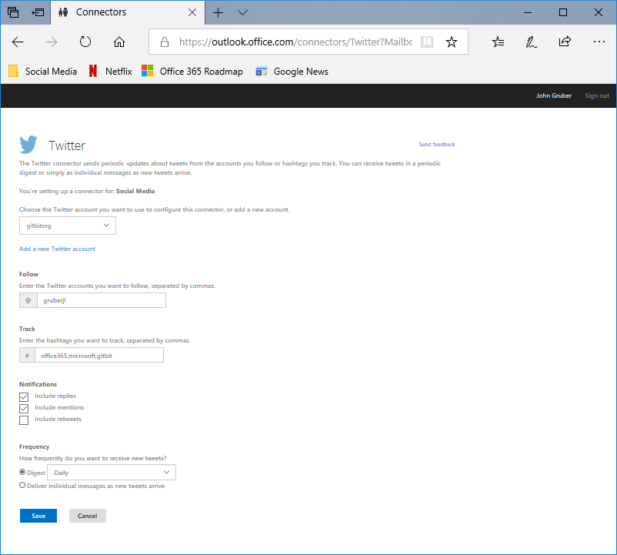

## Setup SharePoint List

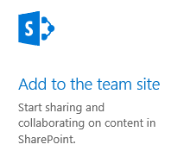

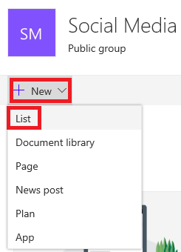

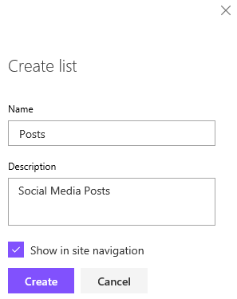

## Setup List

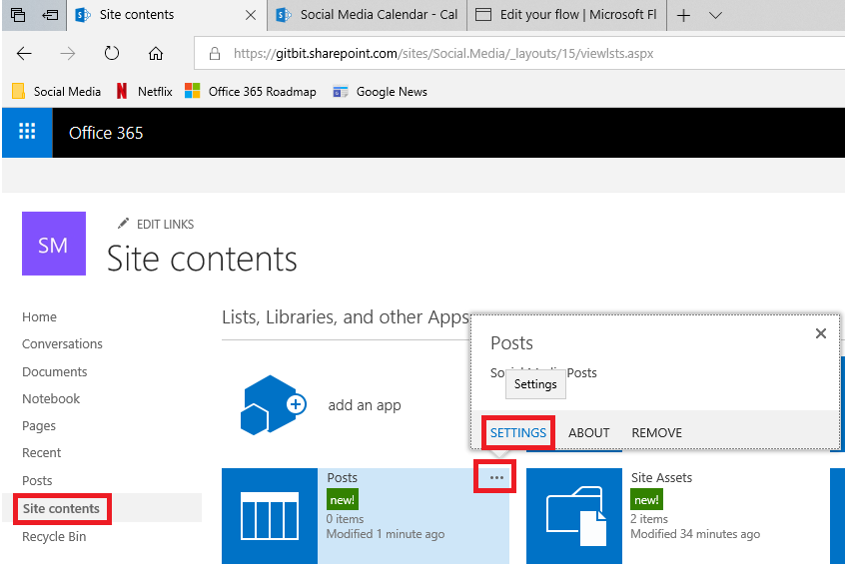

### Create Column

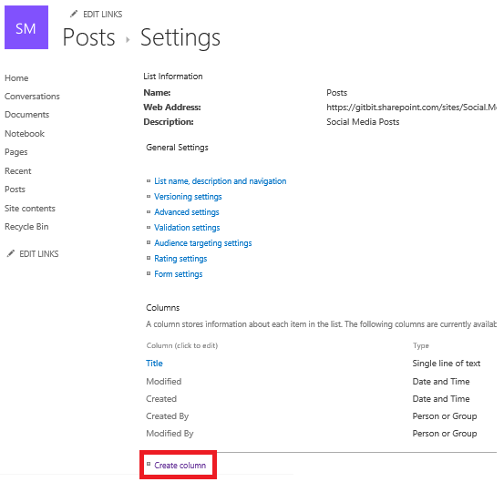

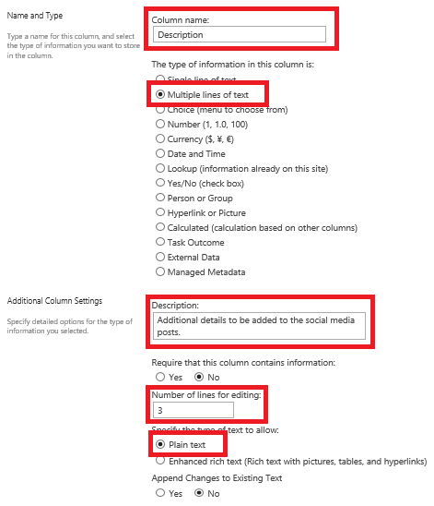

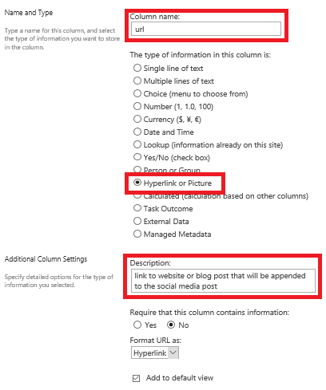

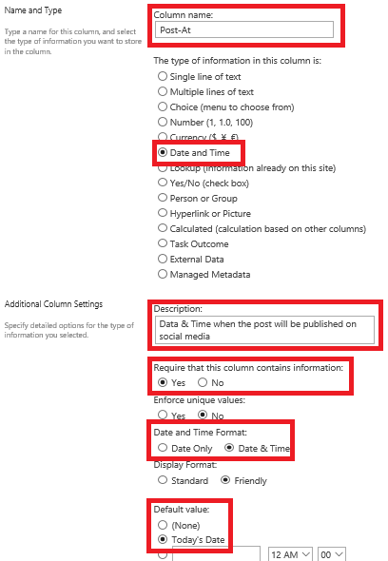

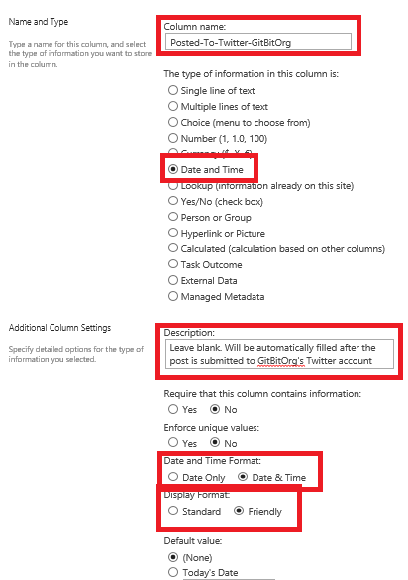

## Configure Approval Constraint

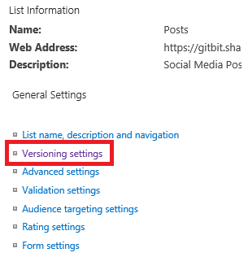

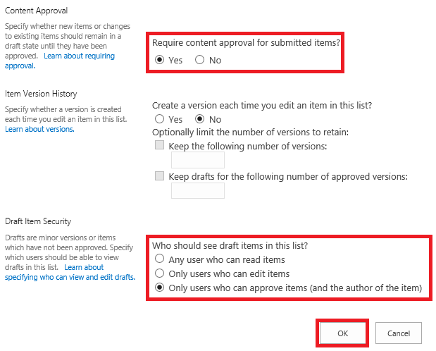

### Approval Status

If someone submits an item to a list or library that requires approvals, it is in Pending status until someone (who has at least Manage Lists permissions level) approves it. While it is awaiting approval, it remains in **Pending** status.

Usually, when an item is in Pending status, only the item originator and the people who have permissions to manage lists and libraries can see it. After its status changes from **Pending** to **Approved**, it becomes visible to anyone who has permission to view the list or library. Rejected articles stay in the list or library until the originator—or someone else who has the necessary permissions—deletes them. Any items or files that already exist in the list or library are granted **Approved** status automatically.

**Important:**  If security in the site library is configured to allow any user to read items, then anyone who has Read permissions to the site can see all items in the list or library, whether the items are in **Approved** status.

Only persons who have Full Control or Design permissions can alter List or Library settings.

## Configure Approvers

Are group owners the approvers?

## Create a Team

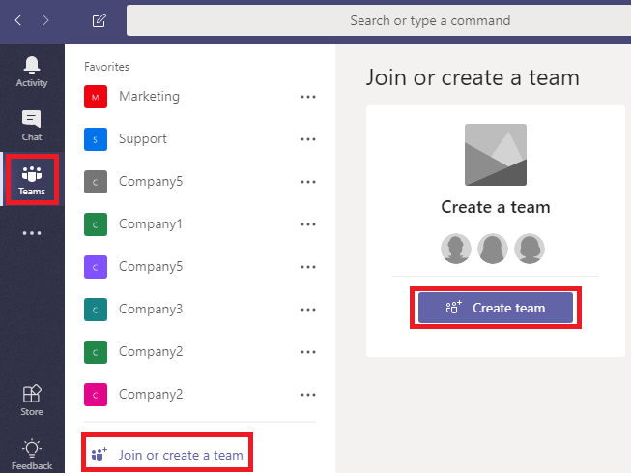

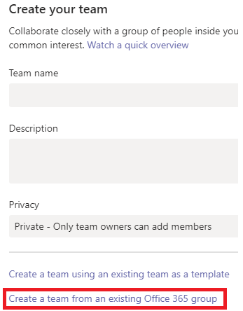

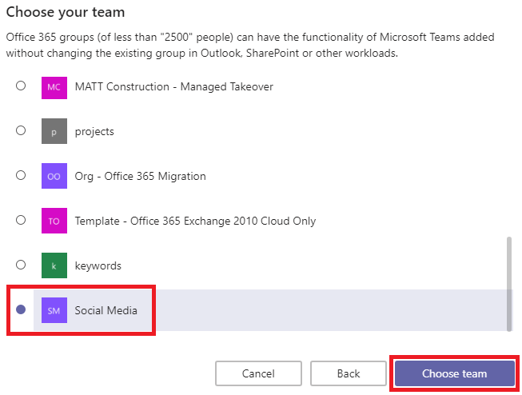

## Create an Approval Workflow

<https://gitbit.sharepoint.com/sites/Social.Media>

## Approving a Post

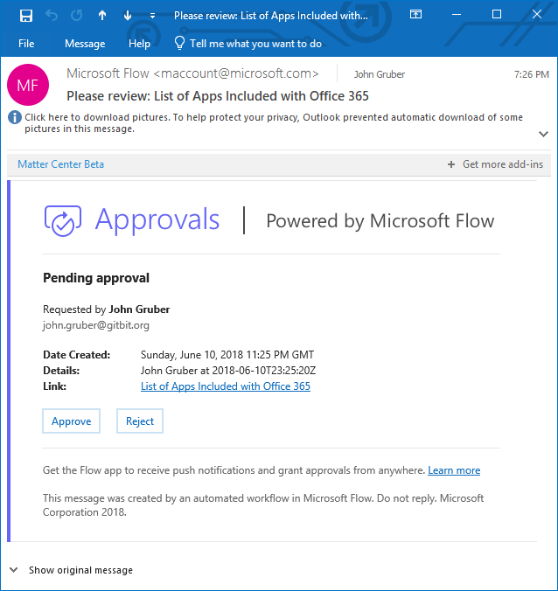

To approve a document that has been uploaded or added to a library that requires approvals, follow these steps:

1. Click the ellipses (**...**) next to the item you want to approve.
2. Click **Advanced**.
3. Click **Approve/Reject**. If **Approve/Reject** doesn't appear, click **Advanced**, and then click **Approve/Reject**. If the option doesn't appear at all, versioning may not be enabled, or you may not have permissions to approve a document.
4. Click **Approved** or **Rejected** under approval status. Optionally you can add comments in the **comment** section.
5. Click **OK**.

## Adding Additional Social Media Profiles

Browse the connectors: <https://us.flow.microsoft.com/en-us/connectors/?filter=&category=standard>

## More Information

https://docs.microsoft.com/en-us/flow/sequential-modern-approvals